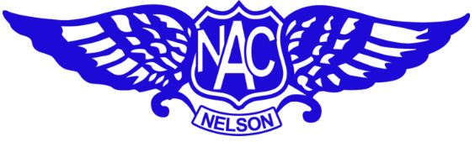

**Nelson Aero Club**

**Pricing**

(Effective from August 2025)

Cessna 152: $275/hr Solo, $345/hr Dual

Cessna 172: $335/hr Solo, $405/hr Dual

Landing Fee: (Nelson) $25 (Cessna 152) $32.41 (Cessna 172)

Circuits: (Nelson): $5 per circuit

Circuits: (Motueka): $10 - no limit of circuits in one flight

Landing/Airways Fees at other airports are charged as incurred

*********************************************

Instructor Fee (own aircraft): $70 per hour

Ground Fee: $70 per hour of instruction

BFR Fee*: $287.50 & Aircraft hire

********************************************

Flight Plan via Internet:               $6.10

Flight Plan via phone/radio: $10

Int. GA – Aerodrome VFR: $6

SAR time (overdue): $50

**All charges are inclusive of GST @ 15%**

**\*(BFR Terms – Must be a club member, fee covers for up to 5 hours of instruction)**